**Smallest & Largest Community**

The city of San Marcos is surveying and is trying to find the smallest and largest community. A community in this case are neighborhoods that are connected by main roads. Given the roads that connect each neighborhood, can you determine what the smallest and the largest community is? We will disregard communities that are less than two neighborhoods big, since those are just isolated neighborhoods.

**Input:** The first line of input contains **C**, the number of roads. The next **C** lines contain two space-separated integers that represent two differently numbered neighborhoods that have a road connecting them.

**Output:** The smallest and largest community as formatted below.

**Example Input:**

5

1 6

2 7

3 8

4 9

2 6

**Example Output:**

Smallest: 2

Largest: 4

**Explanation:** In this example, we have set roads and when we plot them on a graph, it appears as the following:

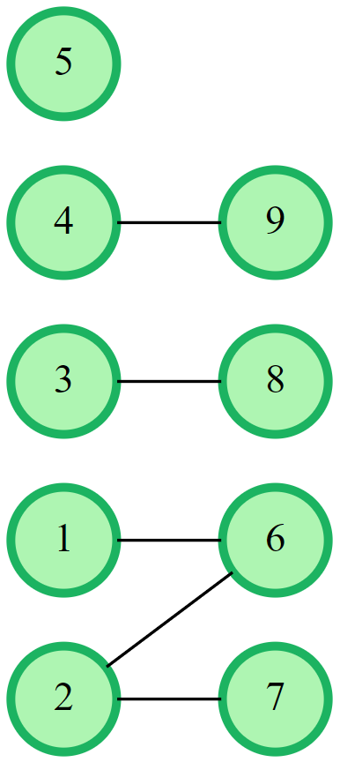

As we can see, the smallest community (with a size greater than or equal to 2) is 2 neighborhoods. We also see based off this graph that the largest community has a size of 4 neighborhoods.